

**Report Title**: Role of OSI Model When We Open Any Website

**Department**: Computer Science and Engineering

**Course Title**: Data Communication

**Course Code**: CSE-303

**Course Teacher**:

Dr. M. Firoz Mridha

Assistant Professor and Coordinator MCSE

University of Asia pacific.

**Submitted By:**

Md Mehedi Hasan

ID: 16201073

Sec: A

Role of OSI Model When We Open Any Website

OSI Model full form is Open Systems Interconnection model. It is a reference model for how applications communicate over a network. We don't use OSI Model in real work networks. We use the TCP/IP Network Model. The OSI model use for understand layers & separating concepts into layers. The OSI model is translated to the TCP/IP model as follows.

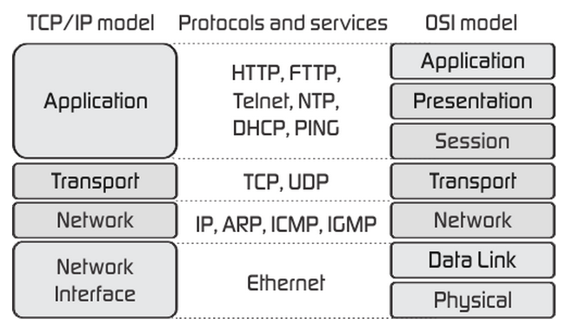

When you are trying to open a web page on our PC this is what typically happens, we type a web address (**URL)** Uniform resource locator in a Web browser **(Chrome, Firefox, Edge).** Web browser uses protocol called (HTTP/HTTPS) Hypertext Transfer Protocol which is an Application layer protocol.

Like Say We Open **University of Asia Pacific** website using this URL **http://www.uap-bd.edu/** we can see from the URL, it's uses **http** protocol and it's not secure.

When we put the URL in a web browser and press enter we see UAP website homepage. Behind the scene the web browser gets the IP address of UAP which is **162.210.102.38** assign into **DNS** Domain Name System **DNS1.SADIQSERVER.COM** & **DNS2.SADIQSERVER.COM** which is also an Application layer protocol.

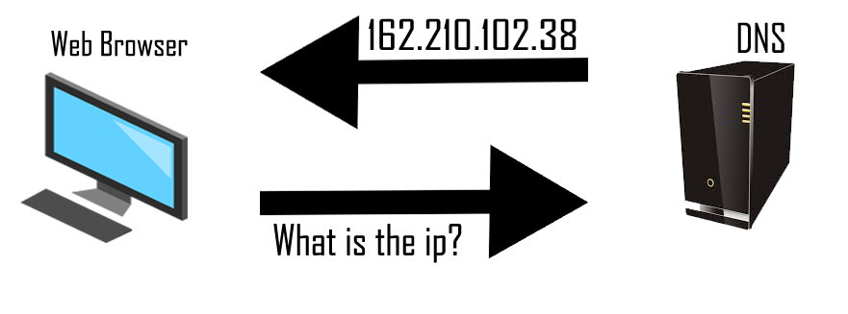

Browser now creates a HTTP packet to get the webpage from the UAP Server (**Apache)** And Server give back an HTML file **(index.html).**

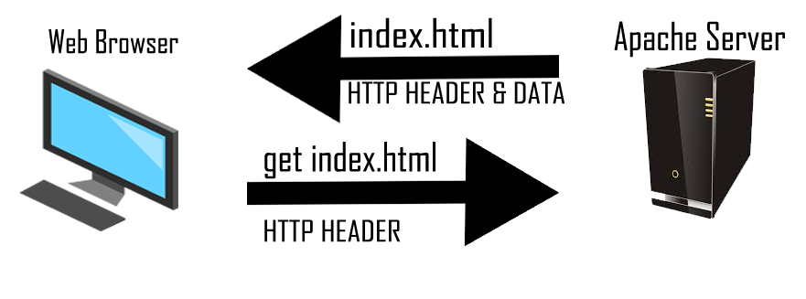

The packet is still in our PC & haven't got out. The browser gives the HTTP packet to a process running in our PC called (**TCP)** Transmission Control Protocol which isa Transport Layer protocol.

This is an adjacent layer interaction on same device i.e. the higher layer (HTTP) asks for the next lower-layer protocol **(TCP)** to perform the service, the lower layer provides a service to the layer above it. This interaction is repeated till the data reaches the last layer.

TCP now handovers the TCP packet to an **IP** process (Internet Protocol) which is an Internet Layer protocol. TCP now put its own info on top of HTTP packet.

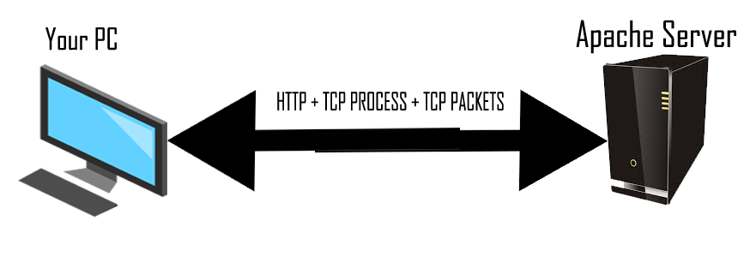

The main job of IP is addressing and routing way to send the packet from our PC to the IP address of UAP. We can imagine IP as a postal service. Postal service has 2 address (sender's and receivers) & they route the letters via different postal offices before delivering it to final destination.

Sender IP Address: **192.168.0.103**

Postal IP Address: **162.210.102.38**

Router IP Address: **27.131.13.12**

IP now handovers the packet to network access/network interface layer. Network access layer defines the protocols and hardware required to deliver data across some physical network which is the physical layer of OSI model.

PC now encapsulates the IP packet between an Ethernet header and Ethernet trailer, creating an Ethernet frame. Ethernet contains something called **MAC** address which is used to send frame locally (Local area network).

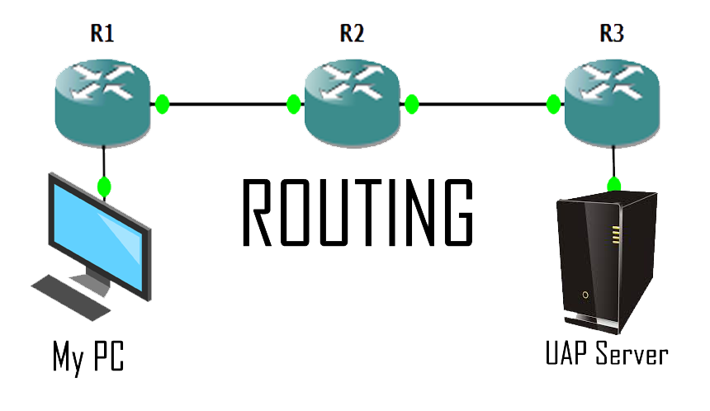

Now our PC physically transmits the bits of this Ethernet frame, using electricity flowing over the Ethernet cabling.

The packet is now out of your PC. It reaches UAP web server. The web server physically receives the electrical signal over a cable, and re-creates the same bits by interpreting the meaning of the electrical signals.

Web server now de-encapsulates the IP packet from the Ethernet frame by removing and discarding the Ethernet header and trailer. Similarly it reads the TCP information and finally hands it over to HTTP process which understands the HTTP get request.

Web server now send sends back to you the web page in the similar steps. Same process repeats, We receive the web page sent by the server which is then shown on our browser.